Bahria University,

Karachi Campus



COURSE: CSC-110 COMPUTING FUNDAMENTALS

TERM: FALL 2020, CLASS: BSE- 1 (B)

Submitted By:

M MUAZ SHAHZAD____________02-131202-081

(Name) (Reg. No.)

Submitted To:

Dr Salahudin/ Engr. Saniya Sarim

Signed Remarks: Score:

INDEX

|  |  |  |  |  |
| --- | --- | --- | --- | --- |
| SNO | DATE | LAB NO | LAB OBJECTIVE | SIGN |
| 1 | 24 Sep | Lab.1 | Introduction to MS WORD and Power Point |  |
| 2 | 01  Oct | Lab.2 | Introduction to MS Excel |  |
|  |  |  |  |  |
|  |  |  |  |  |
|  |  |  |  |  |
|  |  |  |  |  |
|  |  |  |  |  |
|  |  |  |  |  |
|  |  |  |  |  |
|  |  |  |  |  |
|  |  |  |  |  |
|  |  |  |  |  |
|  |  |  |  |  |
|  |  |  |  |  |
| SNO | DATE | LAB NO | LAB OBJECTIVE | SIGN |
|  |  |  |  |  |
|  |  |  |  |  |
|  |  |  |  |  |
|  |  |  |  |  |
|  |  |  |  |  |
|  |  |  |  |  |
|  |  |  |  |  |
|  |  |  |  |  |
|  |  |  |  |  |
|  |  |  |  |  |
|  |  |  |  |  |
|  |  |  |  |  |
|  |  |  |  |  |
|  |  |  |  |  |
|  |  |  |  |  |

Bahria University,

Karachi Campus



LAB EXPERIMENT NO.

**01**

LIST OF TASKS

|  |  |
| --- | --- |
| TASK NO | OBJECTIVE |
| 1 | Have to write a paragraph on news content, event on MS word with title page |
| 2 | Make visiting card in MS WORD |
| 3 | Make presentation on Bahria University in power point |
|  |  |
|  |  |
|  |  |
|  |  |
|  |  |
|  |  |
|  |  |
|  |  |
|  |  |
|  |  |
|  |  |
|  |  |

Submitted On:

__01/10/2020_

(Date: DD/MM/YY)

**Task No. 1: write a paragraph on news content, event on MS word with title page**

**Solution:**

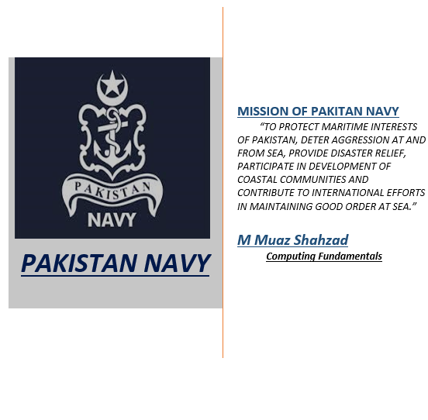

**DEFENDERS OF SEA FRONTIERS**

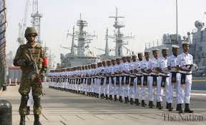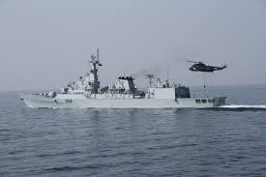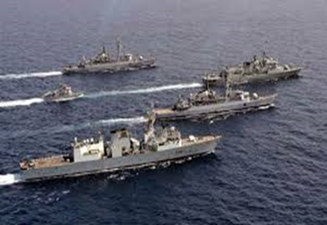The **Pakistan** **Navy** is the **naval warfare** branch of the **Pakistan Armed Forces**. It came into existence by transfer of personnel and equipment from the **Royal Indian Navy** that ceased to exist following the partition of **British India** through a parliamentary act that established the **independence of Pakistan** and India from the United Kingdom on **14 August 1947**. Its primary objective is to ensure the defense of the **sea lines of communication** of Pakistan and safeguarding Pakistan's maritime interests by executing national policies through the **exercise of military effect**, diplomatic and humanitarian activities in support of these objectives. In addition to its war services, the **Navy** has mobilized its war assets to conduct humanitarian rescue operations at home as well as participating in multinational task forces mandated by the **United Nations** to prevent seaborne terrorism and privacy off the coasts. **The Pakistan Navy** is a volunteer force which has been in conflict with neighboring **India** **twice** on its sea borders, and has been repeatedly deployed in the **Indian** **Ocean** to act as a military advisor to Gulf Arab states and other friendly nations during the events of multinational conflict as part of its commitment to the **United Nations**. The Navy has several components including the **Naval** **Aviation**, **Marines**, and the **Maritime Security Agency** (a coast guard).Since its commencement on 14 August 1947, the defensive role of the **Navy** has expanded from securing the sea lines and becoming the custodian of **Pakistan's** **second strike** **capability** **with an ability to launch underwater missile** **system to target enemy positions**.

**The Navy is commanded by** the **Chief of Naval** **Staff,** a four-star admiral, who is a member of the Joint Chiefs of Staff Committee. The Chief of Naval Staff is nominated by the Prime Minister and appointed by the **President of Pakistan**. **The current Chief is Admiral Zafar Mahmood Abbasi who was appointed on 7 October 2017**

**Vice Admiral M Amjad Khan Niazi will take over as Naval chief on 6 October**

**Task No: 2 Make a visiting card in MS word**

**Solution:**

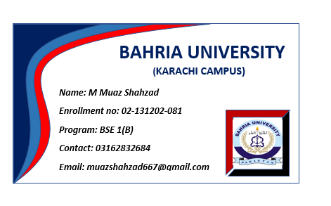

**Task no: 03** Make presentation on Bahria University in Power Point

**Solution:**

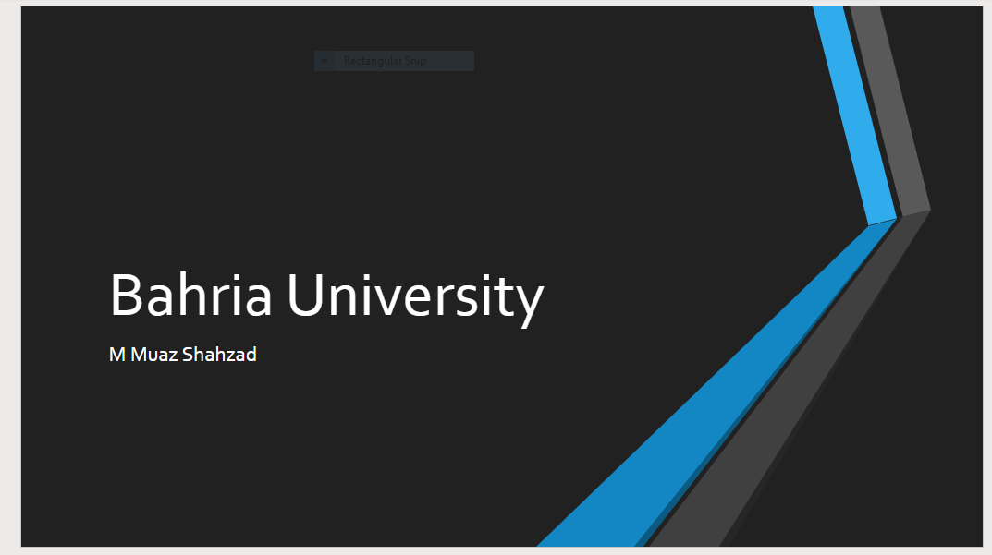

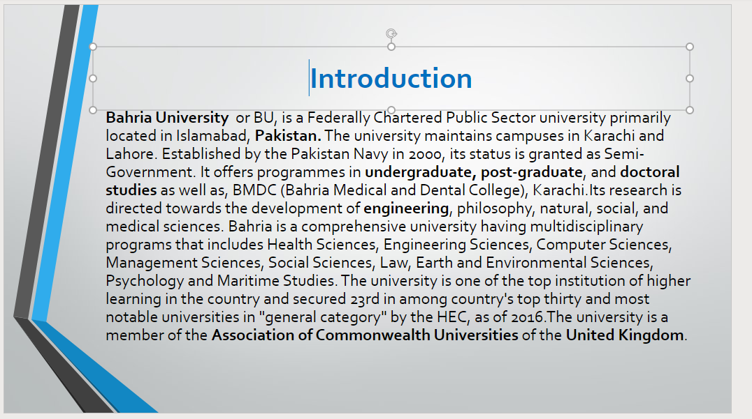

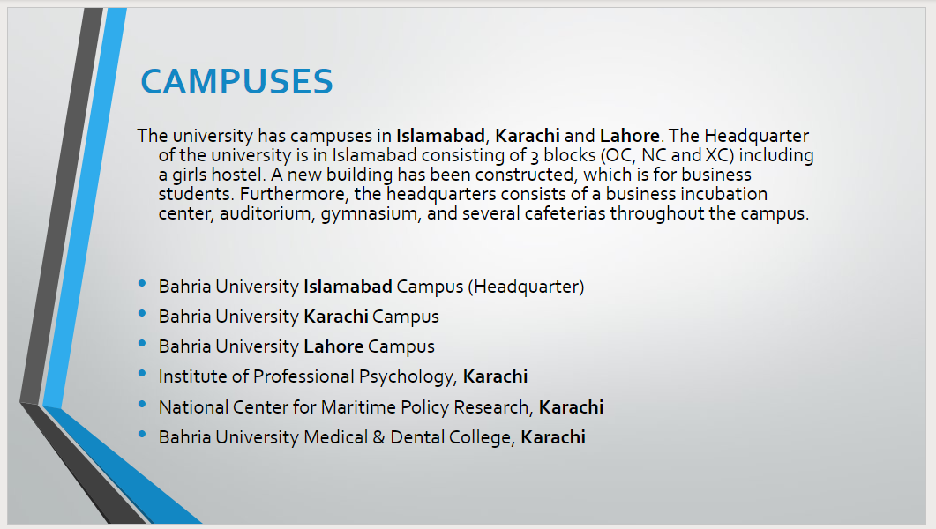

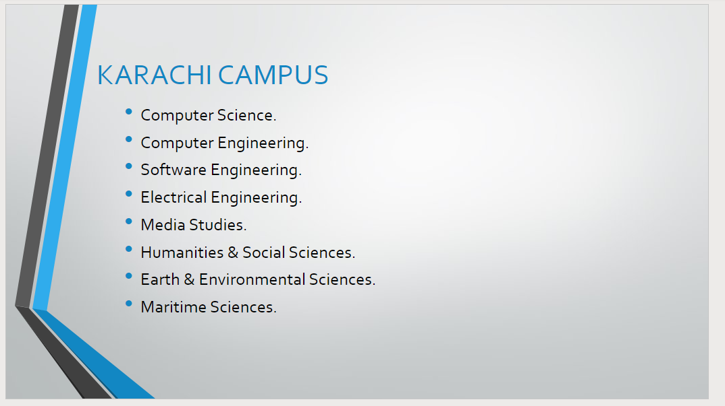

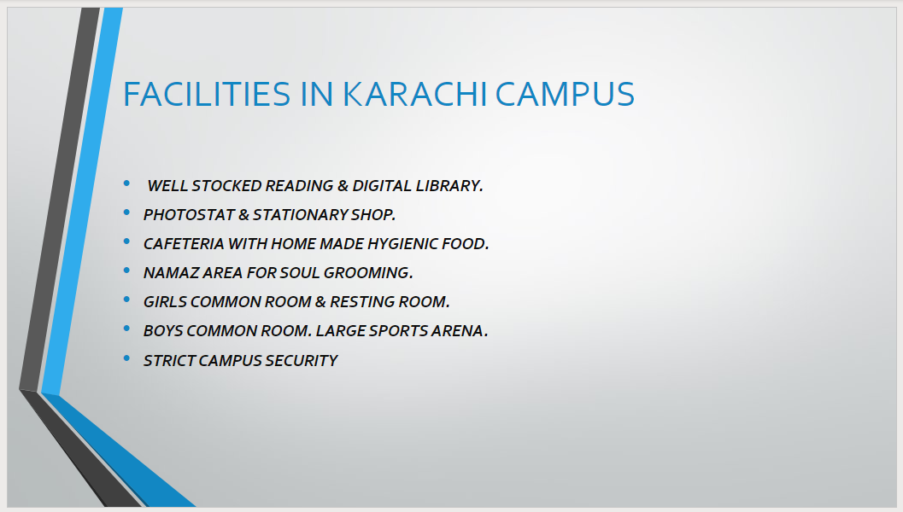



Bahria University,

Karachi Campus



LAB EXPERIMENT NO.

**02**

LIST OF TASKS

|  |  |
| --- | --- |
| TASK NO | OBJECTIVE |
| 1 | Prepare A Marksheet Using Excel |
| 2 | Design Invoice Using Formulas |
| 3 | Design Following Sales Report |
|  |  |
|  |  |
|  |  |
|  |  |
|  |  |
|  |  |
|  |  |
|  |  |
|  |  |
|  |  |
|  |  |
|  |  |

Submitted On:

07/10/2020

**Task No: 1** Prepare a Marksheet Using Excel

**Solution:**

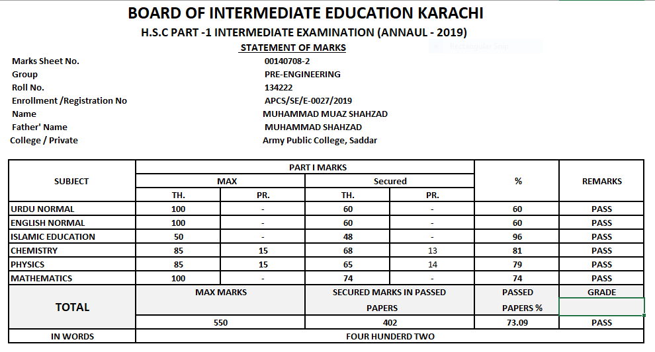

**Task no 2**: Design Invoice using Formulas

**Solution:**

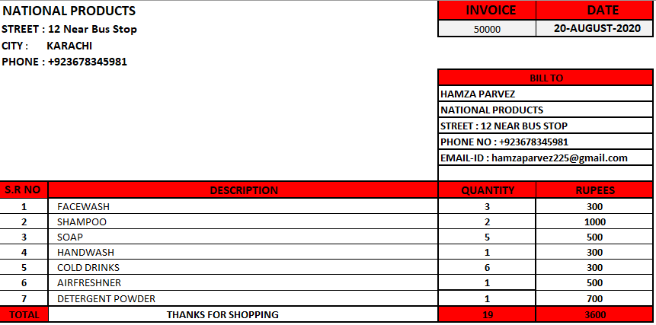

**TASK NO 3**: Design Sales Report

**SOLUTION:** 